Assessment Title: Project Proposal

Student Name: Lee Say Hon

Student ID: 30003628

Date: 11/24/2020

# What data structures are you using?

The data structure which I will be using for this program is doubly linked list for the music player.

# Where are you using hashing techniques?

Hashing technique will be used in the server form create username and password for the client in order for the client to login.

# What sorting algorithm are you using how this is different from selection and bubble sort?

For this application I will be using bubble sort as my sorting algorithm. The way bubble sort work is by comparing each item with the next to it and swapping them around if it is needed. While selection sort arranges the array by finding its largest element and exchanging it with the last element and repeating the process until the whole list is sorted. For both selection and bubble sort, the comparison is always among the unsorted elements and it swap the unsorted elements to create sorted list.

# What search technique are you using?

The search technique which will be used in this project will be the binary search. It is a fast searching algorithm without any run-time complexity. It works base on the principle of divide and conquer. Data needs to be sorted for this algorithm to work.

# What third party libraries are you using?

I will be using LumenWorkCsvReader as the third party library in order to read the CSV files.

# Where can I find the documentation for this?

The documentation of this project will be available on Github. The files will be uploaded to Github to help me keep track of the records of the updates of the application in future.

# A mock-up of the GUI.

Creating account on the server.

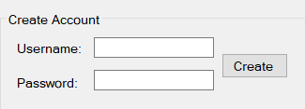

Login function on the Client

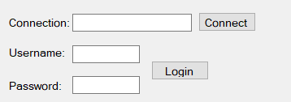

GUI for the media player

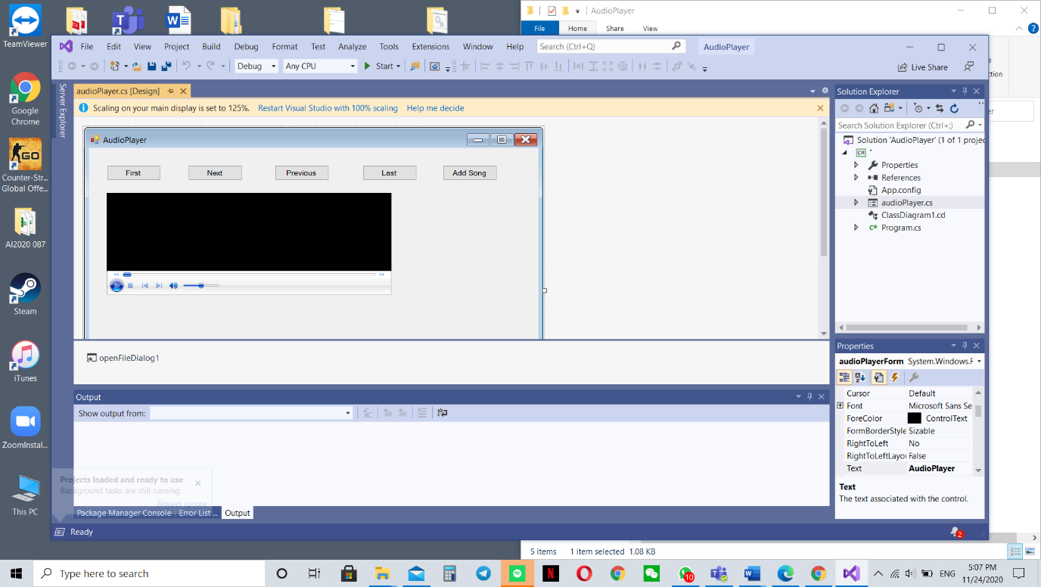

# What source control are you using?

I will be using Github as my source control. It is a web-based hosting service for all developers to share their application with each other. Users will be able to contribute to a open source project and you can also upload your documentation there.

# What are your coding standards you are enforcing?

The coding standard which I will be enforcing for this program is the layout convention and the naming convention.

# What tests are you going to run?

* Debugging of the program once its done
* Able to start server and create account
* User able to login using the created account
* Ability to Display CSV file
* Ability to add songs to music player and play song
* Songs Sorted alphabetically
* Ability to search the song